Dummy variable Creation

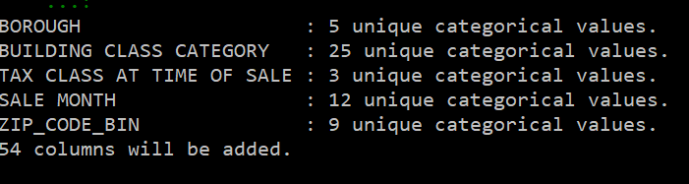

LINEAR Regression using Statsmodels

